Concrete, Pictorial, Abstract
(CPA)

Concrete representation
The children are first introduced to an idea or a skill by acting it out with real objects. In division, for example, this might be done by separating apples into groups of red ones and green ones or by sharing 12 biscuits amongst 6 children. This is a ‘hands on’ approach using real objects and it is the basis for conceptual understanding.
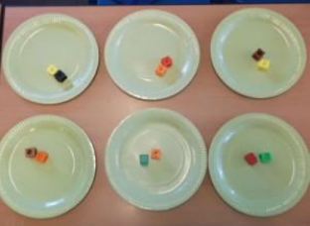

Pictorial representation
This is used when a child has sufficiently understood the hands-on experiences performed and can now relate them to representations, such as a diagram or picture of the problem. In the case of a division exercise this could be the action of circling objects.
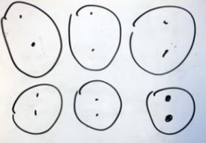

Abstract representation
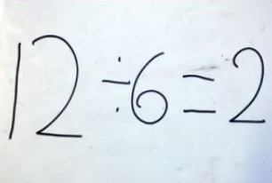
The symbolic stage – a student is now capable of representing problems by using mathematical notation, for example: 12 ÷ 6 = 2. This is clearly the more confusing and mysterious of the three and without the ‘hands on’ and pictorial steps can be very hard for children to understand.

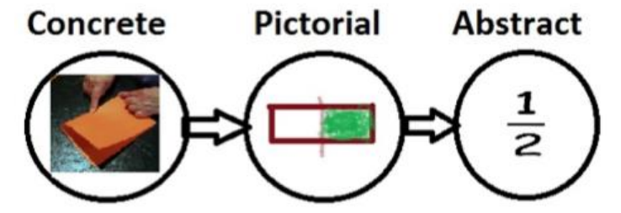
Bringing ‘concrete, pictorial, abstract’ together

Some examples of how Concrete, Pictorial and Abstract could work
45 + 23
CONCRETE PICTORIAL ABSTRACT
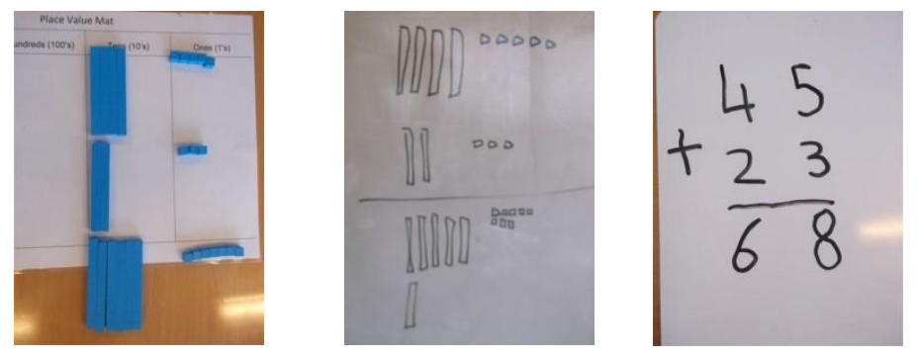

37 ÷ 3
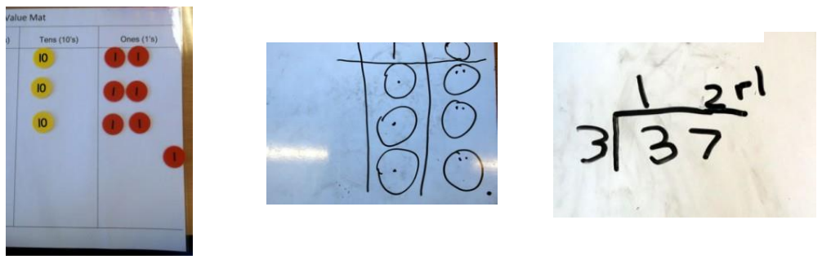
CONCRETE PICTORIAL ABSTRACT

